**Communication Plan**

**Team 4**

Rikdev Bhattacharya

Chen-Wei Huang

Sriram Rajagopalan

Amy Siedlecki

Sriraman Srinivasan

**Contents**

**1.** **Objective:** 2

**2.** **Project Team Directory:** 2

**3.** **Communication Matrix:** 3

**4.** **Decision Making Process:** 3

**5.** **Task Delegation and Tracking:** 4

**6.** **Task Tracker** 4

**7.** **RACI Matrix:** 5

**8.** **File Sharing and Communication:** 5

**9.** **Conflict Management:** 6

**10.** **Communication with Mark:** 6

**11.** **Celebration Plan:** 7

**12.** **Contingency Plan:** 7

**Revision History:** 7

# **Objective:**

The objective of this document is to clearly state our means of communication, frequency of communication, and expectations of communication.  We plan to utilize communication effectively to limit conflict and misunderstanding, but we have also included decision-making processes and conflict resolution techniques in anticipation of any potential problems or disagreements.

# **Project Team Directory:**

The project team directory includes the contact information for each team member, their availability and best times to communicate, as well as their strengths so that team members will know the best person to contact when they face a problem.

|  |  |  |  |  |  |
| --- | --- | --- | --- | --- | --- |
| Name | Contact No. | Email Id | Strengths | Times Unavailable | Best Time to Communicate |
| Amy Siedlecki | 203-671-6721 | [Amy.siedlecki@uconn.edu](mailto:Amy.siedlecki@uconn.edu) | Data analysis, PowerPoint Presentations, Proofreading and editing | 9 – 5:30 Every day; Wednesday all day | Monday and Tuesday after 6:30pm;  Sunday- All day |
| Sriraman Srinivasan (Sri) | 860-997-8492 | [Sriraman.s@uconn.edu](mailto:Sriraman.s@uconn.edu) | Presentation, Documentation, Data Collection/Migration and Analysis. | Monday  Wednesday  Friday | Tuesday  Thursday  Weekends- All Day |
| Sriram Rajagopalan (Ram) | 860-328-6540 | [Sriram.rajagopalan@uconn.edu](mailto:Sriram.rajagopalan@uconn.edu) | MS Office, Presentations and Document Formatting | Monday  Wednesday  Friday | Tuesday  Thursday  Weekends- All Day |
| Chen-Wei Huang (Ted) | 860-977-1601 | Chen-wei.huang@uconn.edu | MS Office, Data Analysis, Information Search | Tuesday,  Wednesday | Monday, Thursday, Friday-Evening, Weekend-All Day |
| Rikdev Bhattacharya (Rick) | 959-999-1253 | Rikdev.bhattacharya@uconn.edu | Proofreading and Editing, PowerPoint Preparation | Monday,  Wednesday | Tuesday, Friday, Saturday and Sunday- All Day |

# **Communication Matrix:**

The communication matrix includes our high level plan for communication throughout the project.   Our primary form of communication will be through texting on the WhatsApp.  In addition to our daily communication through WhatsApp we will have weekly in person meetings on Thursdays from 5:15 to 6:00 as well as weekly conference calls on Sundays.  As the project progresses, we will schedule more meetings if necessary.

|  |  |  |  |
| --- | --- | --- | --- |
| Communication Type | Objective | Medium | Frequency |
| WhatsApp Chat | Answer questions, stay on task, provide updates of progress | Texting on the WhatsApp Chat | As needed |
| Weekly Meetings | Set goals for the week, communicate responsibilities, make decisions on upcoming tasks, finalize prior tasks | In Person: Classroom 407 | Thursdays 5:15pm to 6:00pm |
| Weekly Meetings II | Check in on Progress of weekly goals; Answer questions, provide help and assistance for those who need it | Conference Call | Sunday Evenings as needed |

# **Decision Making Process:**

We will utilize the below Decision Making Flowchart to make our decisions:

* We will start with discussions and eventually convert the conversation into a proposal.
* After the initial proposal, we will test for a group consensus.
* If everyone agrees, we will move forward and begin to take action.
* If we fail to arrive at a consensus, the dissenters will discuss their concerns and then appropriate modifications will be made to the initial proposal.
* If the concerns raised are resolved via discussions, then no further modification is required to the initial proposal and we move forward and begin to take action.
* We may need to make a modification to the proposal and test for consensus again after initial concerns are raised.
* If we are unable to come to a full consensus, we require a majority of 3 from our team to move forward with a proposal and begin to take action.

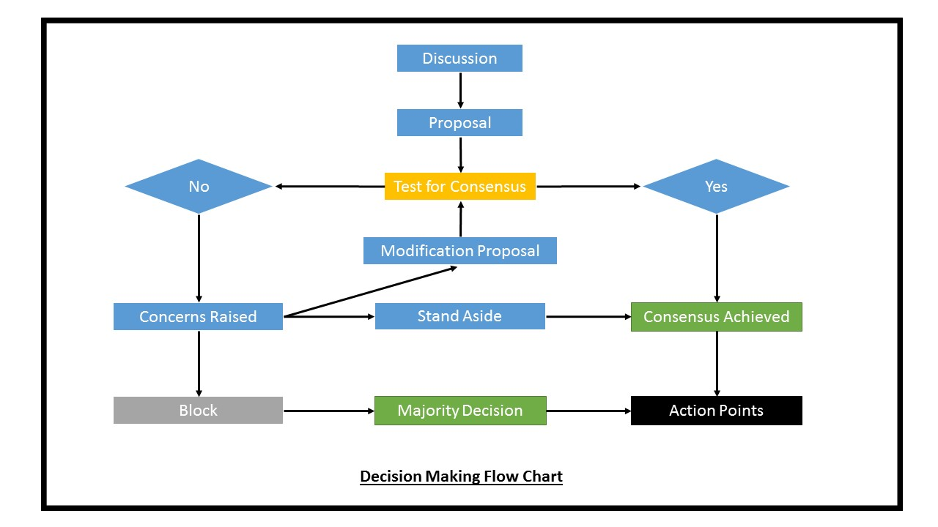

# **Task Delegation and Tracking:**

We will utilize the task tracker as well as a RACI matrix to help manage our project tasks.  This will help us both understand what needs to be done, by whom, and when, as well as help manage the workloads of each individual team member.  We will consider all team members as necessary to inform and we will assign consulting roles on a case-by-case basis (for larger tasks).  We will establish internal/team due dates so that everyone is able to review the work before it is submitted by the external due date.

The task tracker will have the tasks assigned to the team members within a project and the RACI matrix will provide the overall responsibilities of the team members for a particular project.

# **Task Tracker**

|  |  |  |  |  |  |  |  |
| --- | --- | --- | --- | --- | --- | --- | --- |
| Title/Task | Responsible | Accountable | Consult | Inform | Internal Due Date | External  Due Date | Special Instructions |
| Communication Plan Formatting | Ram, Sri | Amy | Rick | Ted | 9/21/2016 | 9/22/2016 | After content is finalized, put communication plan into a nicely formatted document. |

# **RACI Matrix:**

Below is an example of our RACI matrix.  We will keep this as a separate shared document in the “Intro to Project Management – Team 4” Google Drive folder.  All Team members will have access to this document so that they can view and make changes.  All responsibility and accountability changes should be discussed with the team.

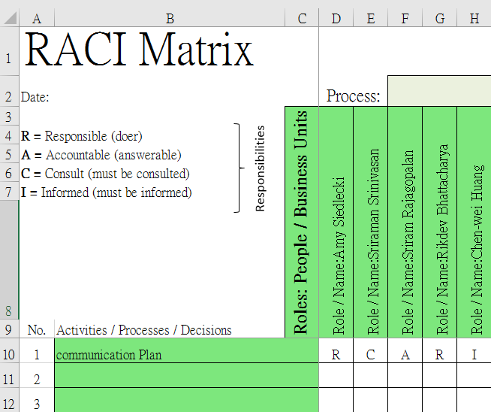

# **File Sharing and Communication:**

All files that are compatible will be shared in Google Drive shared “Intro to Project Management – Team 4” folder for all to access.  Teammates are expected to review and make comments when necessary.  Final submissions will need to be formatted properly outside of Google Drive and into a Microsoft Office document.  Sriram will submit the documents on Husky CT after the final reviews by the team.

# **Conflict Management:**

**Conflict due to difference in ideas/opinions:** All teammates commit to listening to and considering the opinions and ideas of the other teammates.  We will be respectful with our responses, concerns, and feedback.  If there is a strong difference in an opinion amongst the group, both sides will submit their cases and supporting arguments in person and teammates will vote on how to move forward with majority.  If the teammate with a differing opinion does not feel that they had the appropriate opportunity to support their case, they can draft a document explaining the PROs and CONS of their idea.  All team members will then review the document and another vote will occur.  Ultimately, we will move forward with the plan that has a majority of three team members supporting.

**Personal Conflict:** If a teammate has a personal conflict with another member of the team, it is their responsibility to have a conversation with that person and be honest with why they are upset. Both teammates must work towards a solution that will mitigate a conflict moving forward and work to move past the disagreement.  Ultimately we want what is best for the team so at times team members may need to make sacrifices in order to contribute to the team in the best way possible.  We expect all team members to treat each other with respect and commit to the project.

**MSBAPM Conflict Escalation:** If we are unable to resolve any conflicts through the above methods, we will follow the OPIM department escalation process. As stated in the OPIM MSBAPM Team Norms, we will proceed to follow the steps that follow:

1. First have a “face to face” discussion between the conflicted parties within the team. Seek to understand the positions of all the aggrieved parties. If that fails,
2. Meet as a team to attempt to work out the conflict, focusing on the Team Norms previously established. If that fails,
3. Meet as a team with the course instructor. This should be a face-to-face meeting where the instructor(s) will facilitate/mediate a team discussion to surface the underlying issues and seek team resolution to the conflict. If that fails,
4. Meet as a team with the course instructor and program head / department chair.

# **Communication with Mark:**

When questions arise about the direction of the project that we are unable to answer internally, we may need to communicate with the project sponsor.  First, we will ask all members of the team if they know the answer and if we are unable to answer it ourselves, we will designate a team member to compose an email to Mark.  For communication with Mark, we will utilize the newly created Gmail Email address (IntroToPMGroup4@gmail.com) for the team and CC all team members’ UCONN email addresses.

If an in person meeting or conversation is necessary, we will plan to communicate with Mark either before or after class.

# **Celebration Plan:**

The team plans to celebrate our accomplishments periodically and get together in social situations to increase team bonding.

**Tentative Celebration Schedule:**

* November 10th, 2016: Post Class Happy Hour @ City Steam Bar
* December 8th, 2016: Post Class Happy Hour @ Pig’s Eye Pub

# **Contingency Plan:**

The person ‘accountable’ for each task must take care of the risk mitigation activities. It is his/her duty to delegate work after discussion with the team. The timeline for each activity will include a buffer period as well in order to complete the missed activities (if any).  We will establish internal deadlines that are well before the external deadline in order to mitigate the potential for missed tasks. Once the responsibilities are given to each team member, the person accountable must follow up with each team member on a regular timely basis in order to track the completion of work. In case of risks such as work not being completed before deadline due to team member unavailability or any other reason, it has to be delegated to other team members so that it can be completed on time.  Team members will communicate with the team as soon as possible if they begin to think that a task will not be completed by the internal deadline. Similarly, the final submission must also be monitored by the person accountable. If the team member responsible is unavailable to submit the deliverable on time, a secondary member must be assigned so that he/she can take care of the same.

The primary and secondary team members responsible for submission will be fixed and it has to go through them only.

* Primary responsibility for submission: Sriram Rajagopalan
* Secondary responsibility: Sriraman Srinivasan

# **Revision History:**

|  |  |  |  |  |
| --- | --- | --- | --- | --- |
| **Version** | **Prepared by** | **Date** | **Modified by** | **Comments** |
| 1.0 | Amy, Sri, Ram, Rick and Ted | 9/21/2016 | Rick | Minor Formatting Updates |
| 2.0 | Amy, Sri, Ram, Rick and Ted | 10/3/2016 | Amy | Updated section 9 adding MSBAPM Conflict Escalation; Added Section 11 (Celebration Plan) |
| 2.1 | Amy, Sri, Ram, Rick and Ted | 10/3/2016 | Rick | Proof reading and Formatting Updates |